**CPP NOTES – Day 05**

**switch Statement – Multiway Branching**

*switch (expression) {  
case value_1:  
// statements_break.  
break;  
case value_2:  
// statements_2;  
break;  
default:  
// default_statements;  
break;  
}*

* allows you to execute a block of code among many alternatives. It is an alternative to the long if-else-if ladder, providing a cleaner and more readable syntax.

**Else-if Statement**

The else if statement in C++ is used to specify a new condition if the previous condition is false. This allows for multiple conditions to be checked sequentially.

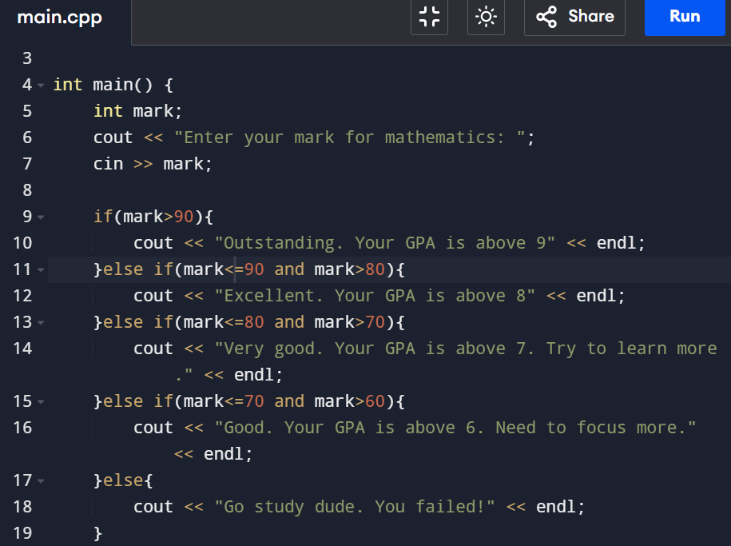

**Developer Test Cases**

* Rainy- A rainy test case is a "negative" test case that is designed to test the system's behavior under unusual, invalid, or unexpected conditions. It's often used to check how the system handles errors or failures.

Eg: In the login functionality, a rainy test case could involve a user entering an incorrect password or a non-existent username to see if the system displays the appropriate error message.

* Sunny - A sunny test case is a "happy path" test case where everything works as expected under normal, ideal conditions. It's the scenario where all inputs are valid, and the system behaves as intended without any errors or exceptions.

Eg: In a login functionality, a sunny test case would be when a user enters a valid username and password and successfully logs in.

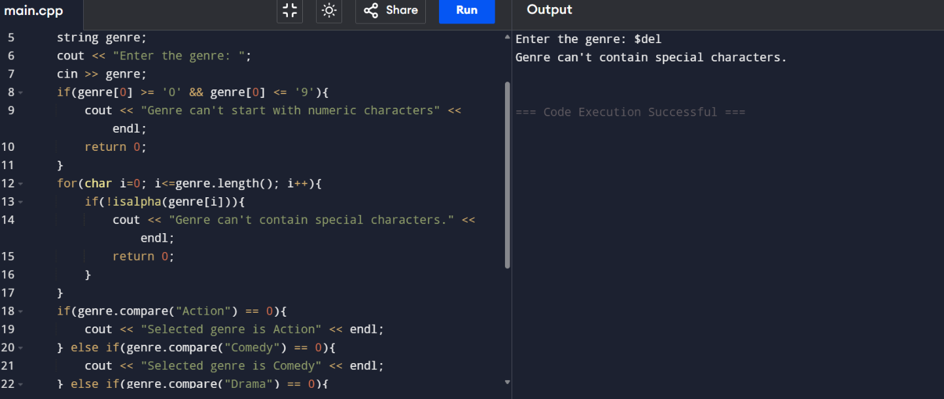

* This code shows the handling of string validation along with else if statements.

*Lambda – a function without a name.*

**Best practices**

* Avoid deep nesting
* Use switch with enum class
* Prefer if const expr for simple cases
* Ternary operator for simple cases
* Don’t forget break in switch

**Goto Statement**

statement in C++ is a jump statement that allows you to jump to another part of the program by specifying a labeled statement. It provides an unconditional jump from the goto statement to a label within the same function.

* Can be used to getout of a nested loop

*goto label;*

*// ... some code*

*label:*

*// code to jump to*

**Flags**

flags are commonly used as indicators that signal whether a certain condition has occurred or if a particular state is active within a program. Flags are typically represented using boolean variables (or sometimes integers, where non-zero values represent "true" and zero represents "false") that can be checked during the flow of the program.

Flags can be used to:

* Control the flow of the program based on specific conditions.
* Indicate whether a certain event or condition has been met, helping the program decide what to do next.